Special Purpose Register

Use the following code and image (the codes are the same) on the following page to answer question 12-15.

The string defined in “MyConstants” area is a reverse polish notation of the math calculation $\left(4+8\right)*(6-3)$. (The code only supports inputs of single digit numbers).

After compiling and initialization, the initial value in the Stack Pointer register (before running the main code) is 0x20000400, the address of the Start label is 0x00000284, and the value in LR register is 0xFFFFFFFF.

THUMB ; use Thumb instruction set

; Constants and code area starts at address 0x0000.0000
AREA MyConstants, DATA, READONLY, ALIGN=2 ; Flash EEPROM

exp DCB "48+63-*",0

ALIGN

; *********************************************************************
; *************************** CODE AREA *******************************
; *********************************************************************

AREA |.text|, CODE, READONLY, ALIGN=2 ; Flash ROM

EXPORT Start

Start ; start executing here

LDR R1, =exp;

evaluate_loop
LDRB R4, [R1], #1
CMP R4, #0
BEQ evaluate_end

CMP R4, #'0'
BLO Calc

SUB R4, R4, #'0'
PUSH {R4}
B evaluate_loop

Calc
POP {R5, R6}
CMP R4, #'+'
BEQ add_operands
CMP R4, #'-'
BEQ sub_operands
CMP R4, #'*'
BEQ mul_operands
CMP R4, #'/'
BEQ div_operands

add_operands
ADD R3, R5, R6
PUSH {R3}
B evaluate_loop
sub_operands
SUB R3, R6, R5
PUSH {R3}
B evaluate_loop
mul_operands
MUL R3, R5, R6
PUSH {R3}
B evaluate_loop
div_operands
SDIV R3, R6, R5
PUSH {R3}
B evaluate_loop

evaluate_end
POP {R3}

ALIGN ; make sure the end of this section is aligned
END ; end of file

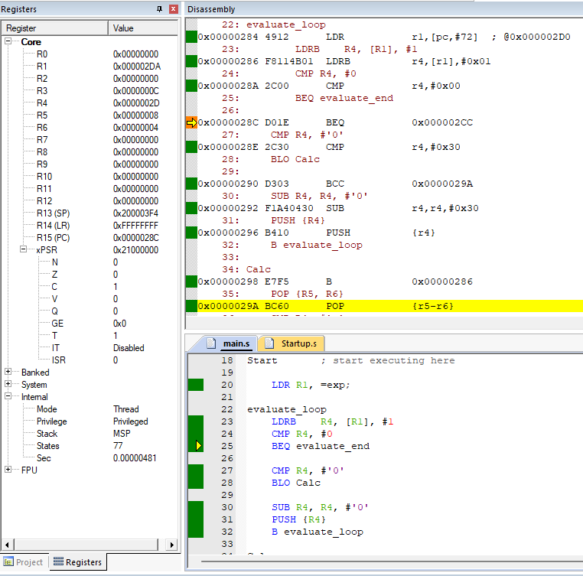

- What is the hexadecimal address will be in the PC register after the instruction on line 25 is executed (immediately after the moment shown in the image)?

Address: 0x________________

- What is the machine code (hexadecimal) for the instruction Line 23 LDRB R4, [R1], #1?

ARM machine code: 0x________________

- At what memory address can you find the instruction Line 31 PUSH {R4}?

Address: 0x________________

- Please show what the following SRAM memory looks like at this moment shown in the image. Assume the SRAM is cleared before running the code. Remember, the POP function will not clear the memory, it only changes the stack pointer.

Address | Values in the memory (A cell means a byte)
0x200003F0
0x200003F8
0x20000400
0x20000408

